**Assignment 1 and 2**

**ICT**



Submitted by:

**Ahmad Bin Mustafa**

**SP23-BCS-011**

**A**

Submitted to:

Dr.Jawad Shafi

Submitted on: **March 21, 2023**

**Department of Computer Science**

**COMSATS University Islamabad**

**Lahore Campus**

**ASSAIGNMENT 1**

**Q1: Write down the Basic features or functionality of the Some Well Known Early computers.**

**The Mark I Computer (1937-44) The Atanasoff-Berry Computer (1939-42)**

**The ENIAC (1943-46) The EDVAC (1946-52)**

**The EDSAC (1947-49) Manchester Mark I (1948)**

**The UNIVAC I (1951)**

**The Mark I Computer (1937-44)**

The Mark I computer, also known as the Harvard Mark I, was an electromechanical computer developed by Howard Aiken and his team at Harvard University between 1937 and 1944. Here are some of its basic features and functionalities:- **1.**The Mark I was an electromechanical computer, which means that it used both electrical and mechanical components to perform its calculations.**2.**The Mark I was huge and weighed around 5 tons. It was approximately 50 feet long and 8 feet tall.**3.**The input data was fed into the computer using punched cards. These cards had holes that represented binary digits (0s and 1s).

**The Atanasoff-Berry Computer (1939-42)**

The Atanasoff-Berry Computer (ABC) was an early electronic digital computer, developed between 1939 and 1942 by John Vincent Atanasoff and Clifford Berry. It had several notable features and functionalities, including:- **1.**The ABC used a binary number system, which allowed for efficient and reliable computation using electronic components.**2.**The ABC used electronic switches called "binary digits," or "bits," to represent and manipulate data. **3.**The ABC could perform multiple calculations simultaneously, using a process called parallel processing. This helped to speed up computations and improve overall efficiency.

**The ENIAC (1943-46)**

The ENIAC (Electronic Numerical Integrator and Computer) was one of the earliest electronic computers built between 1943 and 1946. Its basic features and functionality include:- **1.**The ENIAC was the first electronic computer, which means that it used electronic circuits rather than mechanical or electro-mechanical components.**2.**The ENIAC was massive, taking up an entire room, with over 17,000 vacuum tubes and weighing over 30 tons.**3.**Although the ENIAC was not a general-purpose computer, it was designed to be reprogrammed to solve different problems by physically rewiring its circuits.

**The EDVAC (1946-52)**

The EDVAC (Electronic Discrete Variable Automatic Computer) was a stored-program computer designed in the mid-1940s and completed in 1951. Its basic features and functionality include:- **1.**The EDVAC was faster than its predecessor, the ENIAC, with a processing speed of about 5000 instructions per second.**2.**The EDVAC used binary arithmetic, which allowed for faster calculations and more efficient use of memory.**3.**The EDVAC was equipped with magnetic tape storage, which allowed for more efficient and reliable storage of data and programs.

**The EDSAC (1947-49)**

The EDSAC (Electronic Delay Storage Automatic Calculator) was an early electronic computer built in the late 1940s. Its basic features and functionality include:- **1.**The EDSAC was an all-electronic computer, using vacuum tubes and mercury delay lines for memory.**2.**The EDSAC was the second computer to use stored-program architecture, allowing both data and instructions to be stored in memory.**3.**Like most early computers, the EDSAC used binary arithmetic.

**Manchester Mark I (1948)**

The Manchester Mark I, also known as the Manchester Automatic Digital Machine (MADM), was one of the earliest stored-program computers built in the late 1940s. Its basic features and functionality include:-**1.**The Manchester Mark I was an all-electronic computer, using vacuum tubes and cathode ray tubes for memory.**2.**The Manchester Mark I had a processing speed of about 1,100 instructions per second.**3.**Like most early computers, the Manchester Mark I used binary arithmetic.

**The UNIVAC I (1951)**

The UNIVAC I was the first commercially available electronic computer and was designed and built by J. Presper Eckert and John Mauchly in 1951. It had the following basic features and functionalities:- **1.**The UNIVAC I could perform about 1,000 calculations per second, which was much faster than any other computer at that time.**2.**The UNIVAC I had a memory capacity of 1,000 words (each word consisting of 12 characters), which was considered to be quite large at that time. **3.**The UNIVAC I was equipped with several input and output devices, including punched cards, magnetic tapes, and printers.

**ASSIGNMENT 2**

**Q1: Write down details about ASCII and their Table representation of ASCII 7 & ASCII 8.**

**ASCII**

**INTRODUCTION:** ASCII stands for the American Standard Code for Information Interchange. It is a character encoding system that assigns unique numeric codes to represent characters, symbols, and control characters used in computers, communication systems, and other electronic devices.

**ORIGIN:** ASCII was developed in the 1960s by the American National Standards Institute (ANSI) as a standardized way to represent characters in digital form. It uses a 7-bit binary code to represent 128 different characters, including uppercase and lowercase letters, numbers, punctuation marks, and various special characters.

**CHARACTERS IN ASCII:** The ASCII character set includes 95 printable characters and 33 non-printable control characters. The printable characters include the letters A-Z and a-z, the digits 0-9, and various symbols such as punctuation marks, currency symbols, and mathematical operators. The non-printable control characters include functions such as backspace, carriage return, and line feed.

**SCOPE:** ASCII has been widely used in the computer industry and has been adopted as a standard by many organizations. It has been used as the basis for other character encoding systems, including the extended ASCII and Unicode character sets.

**ADVANTAGE AND DISADVANTAGE:** One of the advantages of ASCII is that it is a simple and well-established encoding system that can be easily understood and implemented by computers and other devices. However, one of its limitations is that it only supports a limited number of characters, which makes it unsuitable for representing characters from languages that use non-Latin scripts. To address this limitation, other character encoding systems, such as Unicode, have been developed to support a wider range of characters.

**Table representation of ASCII 7 and ASCII 8**

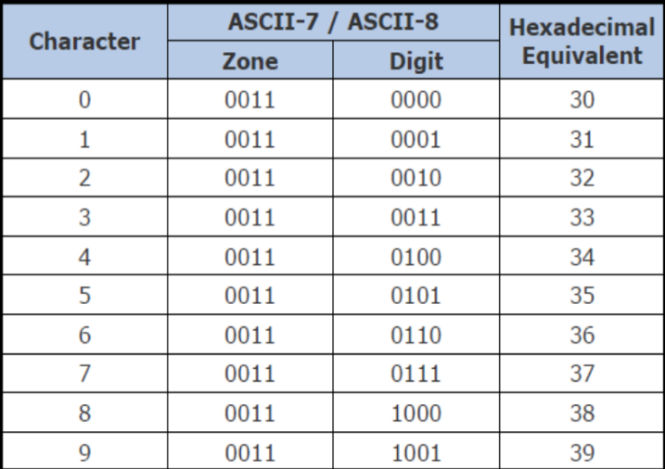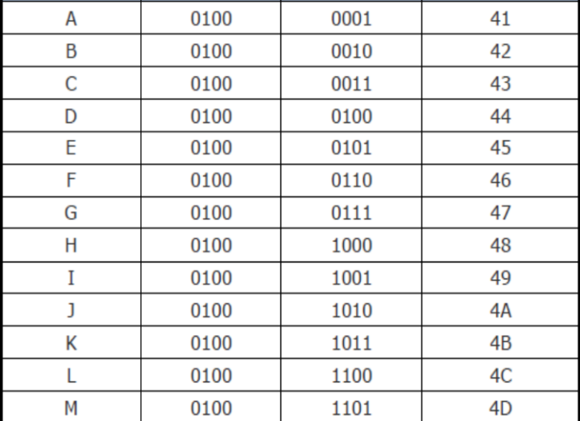

ANOTHER TABLE

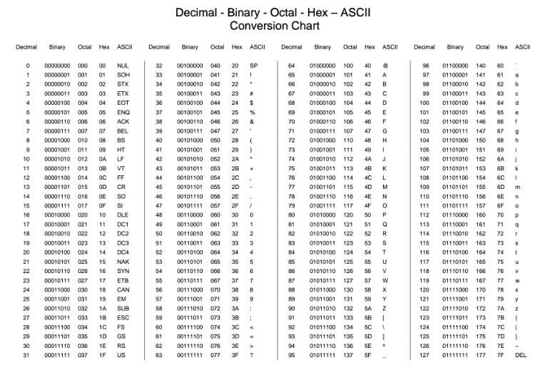

THE END